Supplementary study material

Figure 1: Study flow diagram

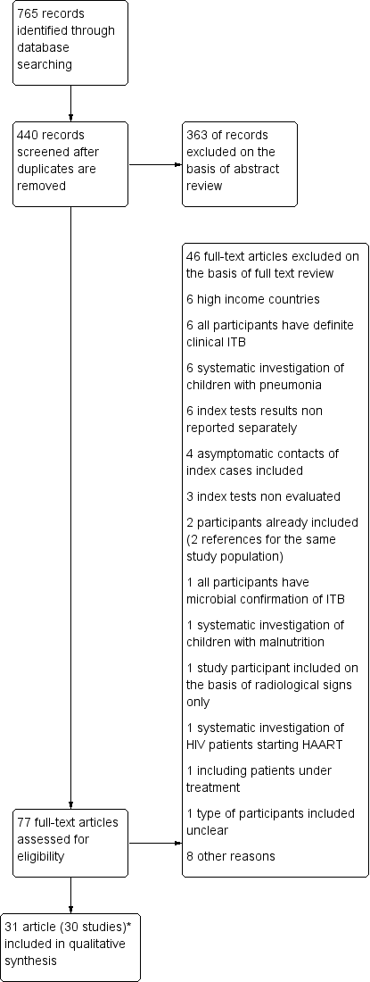

*Mukherjee 2013 (culture) and Singh 2015 (Xpert) are from the same study .

Table 1: Adapted QUADDAS



Figure 2: Risk of bias and applicability concerns graph: review authors' judgements about each domain presented as percentages across included studies (number of studies)

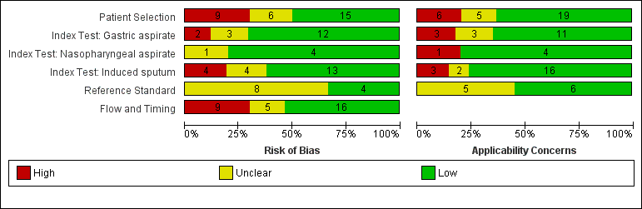

Comparison between index tests

Figure 3: Risk of bias and applicability concerns summary: review authors' judgements about each domain for each included study

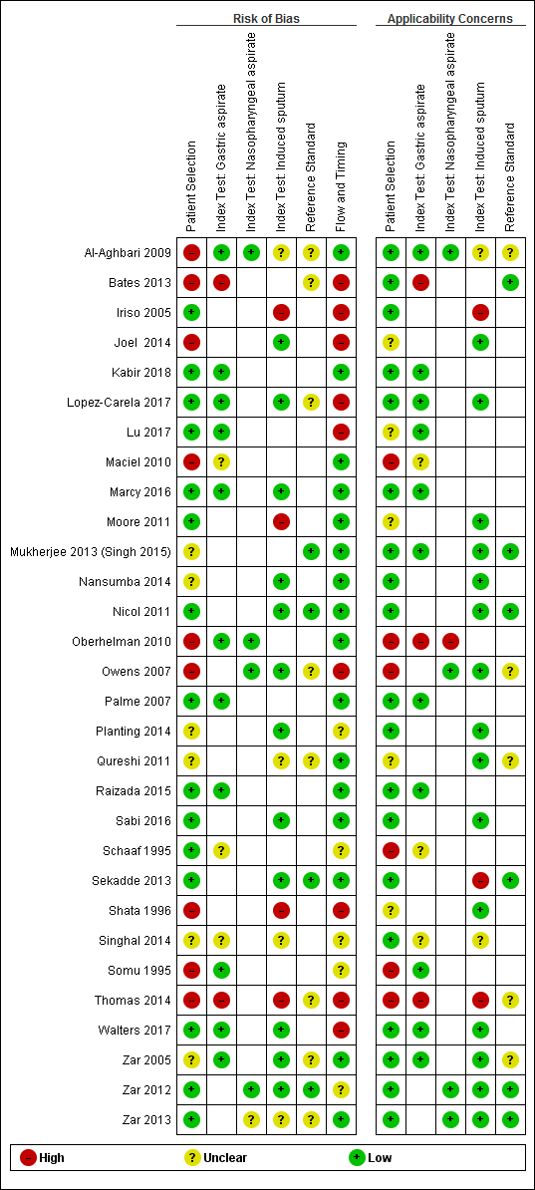

Comparison between index tests tests

Comparison between index tests tests

Table 2: Pre-test clinical probability according to study definition of clinical suspicion of ITB

|  |  |  |  |  |  |  |  |  |  |  |  |  |  |  |  |  |  |  |  |  |
| --- | --- | --- | --- | --- | --- | --- | --- | --- | --- | --- | --- | --- | --- | --- | --- | --- | --- | --- | --- | --- |
|  | **Al-Aghbari 2009** | **Bates 2013** | **Iriso 2005** | **Joël 2014** | **Kabir 2018** | | **Lopez-Verala 2017** | | **Lu 2017** | **Maciel 2010** | **Marcy 2016** | **Moore 2010** | **Mukherjee 2013** | | **Nansumba 2016** | | | **Nicol 2011** | **Oberhelman 2010** | **Owens 2007** |
| **Pre-test clinical probability of ITB** | **LP** | **LP** | **HP** | **I** | **HP** | | **I** | | **HP** | **MP** | **LP** | **MP** | **HP** | | **MP** | | | **MP** | **MP** | **HP** |
| Symptom complex suggestive of ITB |  |  |  |  |  | |  | |  |  |  |  |  | | x | | |  |  |  |
| Cough more than 2 weeks |  | x | x |  | x | |  | | x | x | x | x | x | |  | | | x | x | x |
| Weight loss or failure to gain weight | x | x | x |  | x | |  | |  | x | x | x | x | |  | | | x |  | x |
| Fever of more than 1 or 2 weeks |  |  |  |  | x | |  | | x |  | x |  | x | |  | | |  |  |  |
| Painless swelling of superficial nodes |  |  | x |  | x | |  | |  |  |  |  |  | |  | | |  |  |  |
| History of contact with cases of ITB | x | x | x |  | x | |  | | x | x |  |  | x | | x | | | x | x |  |
| X-ray findings suggestive of ITB or abnormal CXR | x |  |  |  | x | |  | |  | x | x |  |  | | x | | | x | x | x |
| Positive tuberculin skin test |  |  |  |  | x | |  | | x | x |  | x |  | | x | | | x | x | x |
| Persistance of symptoms or radiological abnormalities after standard antibiotic treatment | x |  | x |  | x | |  | |  |  | x | x | x | | x | | |  |  | x |
|  |  |  |  |  |  |  | |  |  |  |  | |  |  | |  |  |  |  | |  |  |  |  |  |
|  | **Palme 2007** | **Planting 2014** | **Qureshi 2011** | **Raizada**  **2015** | **Sabi 2016** | **Schaaf 1995** | | **Sekadde 2013** | **Shata1996** | **Singhal**  **2014** | **Somu 1995** | **Thomas 2014** | **Walters 2017** | | **Zar 2005** | | **Zar 2012** | **Zar 2013** |
| **Pre-test clinical probability of ITB** | **HP** | **MP** | **MP** | **LP** | **LP** | **HP** | | **MP** | **I** | **I** | **HP** | **LP** | **LP** | | **MP** | | **MP** | **MP** |
| Symptom complex suggestive of ITB | x |  |  |  |  |  | |  |  |  |  |  |  | |  | |  |  |
| Cough more than 2 weeks |  | x | x | x | x |  | | x |  |  | x | x | x | | x | | x | x |
| Weight loss or failure to gain weight |  | x | x | x | x | x | | x |  |  |  |  | x | | x | | x | x |
| Fever of more than 1 or 2 weeks |  |  |  | x | x |  | | x |  |  |  |  | x | |  | |  |  |
| Painless swelling of superficial nodes |  |  |  |  |  | x | |  |  |  |  | x |  | |  | |  |  |
| History of contact with cases of PTB | x | x | x |  | x | x | | x |  |  |  | x | x | | x | | x | x |
| X-ray findings suggestive of ITB or abnormal CXR | x | x | x |  |  |  | |  |  |  | x | x | x | | x | | x | x |
| Positive tuberculin skin test | x | x | x |  |  |  | |  |  |  |  |  | x | | x | | x | x |
| Persistance of symptoms or radiological abnormalities after standard antibiotic treatment |  |  |  |  |  | x | |  |  |  | x | x |  | |  | |  |  |

HP: high probability; MP: moderate probability; LP: low probability; I: indeterminate

Table 3: Sputum induction procedure across studies

|  |  |  |  |  |  |  |  |  |  |  |  |
| --- | --- | --- | --- | --- | --- | --- | --- | --- | --- | --- | --- |
|  | *Fasting time* | *Broncho-dilator before induction* | *Type of nebulizer* | *Nebulization solution* | *N. of ml* | *N. of mn* | *Chest physio.* | *Negative pressure for suction* | *Training* | *Proportion ES* | *Time to lab process.* |
| **Al-Aghbari 2009** | U | Y | U | 5% saline | 5 | 15 | Y | U | U | U | U |
| **Iriso 2005** | U | N | U | 3% saline | 5 to 10 | U | N | manual | U | 0% | U |
| **Joel 2014** | U | Y | Ultrasonic | 3% or 5% saline | U | 15 | N | 20mmHg | U | 0% | <7 days |
| **Lopez-Varela 2017** | U | Y | U | 3% saline | 5 to 7 | U | N | U | U | 0% | <4h |
| **Moore 2011** | 2-3h | Y | U | 5% saline | 5 | 15 | N | U | Y | 60% | <24h |
| **Mukherjee 2013** | 6-8h | Y | U | 3% saline | 3 | 15 to 20 | Y | U | Y | U | 1-2h |
| **Nansumba 2014** | 2h | Y | Ultrasonic | 5% saline | 5 | 20 | N | U | Y | U | U |
| **Nicol 2011** | 2-3h | Y | Jet | 5% saline | 5 | 15 | Y | U | Y | 0% | 2h |
| **Owens 2011** | U | Y | U | 5% saline | 15 | 20 | N | U | U | 0% | <12h |
| **Planting 2011** | 2-3h | Y | Jet | 5% saline | 5 | 15 | N | 40-50 kPa | Y | 21% | 2h |
| **Qureshi 2011** | 2-3h | U | U | U | U | U | Y | U | U | 0% ? | U |
| **Sabi 2016** | U | Y | Jet | 5% saline | 5 | 15 | N | U | Y | 1.6% | <1h |
| **Sekadde 2013** | 3h | Y | U | 3% saline | U | U | N | U | Y | all ? | <2h |
| **Shata 1996** | U | N | Ultrasonic | 3% saline | 5 to 10 | 10 to 20 | N | U | U | U | U |
| **Singhal 2014** | U | U | U | U | U | U | U | U | U | U | U |
| **Thomas 2014** | 2-3h | Y | U | 3% saline | 5 | 15 | Y | U | U | U | < 24h |
| **Walters 2017** | 2-3h | Y | Jet | 5% saline | 5 | 15 | Y | 80-120 mmHg | Y | U | <4h |
| **Zar 2005** | 2-3h | Y | Jet | 5% saline | 5 | 15 | Y | U | Y | 0% | <2h |
| **Zar 2012** | 2-3h | Y | Jet | 5% saline | 5 | 15 | Y | U | Y | 0% | <2h |
| **Zar 2013** | 2-3h | Y | Jet | 5% saline | 5 | 15 | Y | U | Y | 0% | <2h |

U: unknown; Y: yes;

Table 4: Yield of culture according to sputum collection method

|  |  |  |  |  |
| --- | --- | --- | --- | --- |
| **Definition Presumptive tuberculosis** | **Specimen** | **Study** | **Yield 1st sample** | **Add Yield 2nd sample** |
| Low probability | GA | Al-Aghbari 2009 | 9% [5-14] | 1% [0-3] |
|  |  | Bates 2013 | 6% [5-8] |  |
|  |  | Raizada 2015 | 7% [6-8] |  |
|  |  | Walters 2017 | 13% [9-17] |  |
|  |  | Thomas 2014 | 11% [4-23] |  |
|  | NPA | Al-Aghbari 2009 | 7% [4-11] |  |
|  |  | Marcy 2016 | 8% [5-12] |  |
|  | IS | Al-Aghbari 2009 | 15% [8-24] | 1% [0-7] |
|  |  | Sabi 2016 | 5% [2-9] |  |
|  |  | Walters 2017 | 9% [6-13] |  |
| Moderate probability | GA | Oberhelman 2010 | 7% [4-12] | 3% [1-6] |
|  |  |  |  |  |
|  |  | Zar 2005 | 8% [5-12] |  |
|  |  | Maciel 2010 | 10% [4-20] | 9% [3-18] |
|  | NPA | Oberhelman 2010 | 4% [2-7] | 2% [1-5] |
|  |  | Zar 2012 | 10% [7-13] | 3% [1-5] |
|  | IS | Moore 2011 | 3% [2-6] | 1% [0-4] |
|  |  | Nansumba 2014 | 10% [5-16] |  |
|  |  | Nicol 2011 | 13% [10-17] | 2% [1-4] |
|  |  | Planting 2014 | 17% [14-20] | 2% [1-4] |
|  |  | Sekkade 2013 | 14% [10-19] |  |
|  |  | Thomas 2014 | 8% [3-17] |  |
|  |  | Zar 2005 | 15% [11-20] |  |
|  |  | Zar 2012 | 13% [10-17] | 2% [1-4] |
|  |  | Zar 2013 | 8% [5-11] | 1% [0-3] |
| High probability | GA | Kabir 2018 | 13% [7-22] |  |
|  |  | Lu 2017 | 17% [11-24] |  |
|  |  | Mukherjee 2013 | 23% [19-27] | 10% [7-13] |
|  |  | Palme 2007 | 45% [39-51] | 6% [4-10] |
|  |  | Schaaf 1995 | 40% [34-47] | 4% [2-9] |
|  |  | Somu 1995 | 30% [18-45] | 2% [0-11] |
|  | NPA | Owens 2007 | 24% [15-34] |  |
|  | IS | Iriso 2005 | 30% [21-40] |  |
|  |  | Mukherjee 2013 | 12% [9-15] | 6% [4-9] |
|  |  | Owens 2007 | 22% [14-32] |  |
| Indeterminate probability | GA | Lopez-Verala 2017 | 1% [0-2] |  |
|  |  |  |  |  |
|  |  | Singhal 2014 |  | 0% [0-8] |
|  | IS | Joel 2014 | 6% [5-7] |  |
|  |  | Lopez-Verala 2017 | 1% [0-1] |  |
|  |  | Shata 1996 | 24% [10-44] |  |
|  |  | Singhal 2014 |  | 7% [1-19] |

GA: gastric aspirate; NPA: nasopharyngeal aspirate; IS: induced sputum

Table 5: Yield of Xpert MTB-RIF® according to sputum collection method

|  |  |  |  |  |
| --- | --- | --- | --- | --- |
| **Definition presumptive tuberculosis** | **Specimen** | **Study** | **Yield 1st sample** | **Add. Yield 2nd sample** |
| Low probability | GA | Bates 2013 | 5% [3-7] |  |
|  |  | Raizada 2015 | 6% [5-7] |  |
|  |  | Walters 2017 | 7% [4-11] |  |
|  | NPA | Marcy 2016 | 8% [5-12] |  |
|  | IS | Sabi 2016 | 2% [0-5] |  |
|  |  | Walters 2017 | 6% [3-9] |  |
| Moderate probability | NPA | Zar 2012 | 8% [5-12] | 3% [1-5] |
|  |  | Zar 2013 | 3% [1-5] | 1% [0-3] |
|  | IS | Nansumba 2016 | 7% [3-15] |  |
|  |  | Nicol 2011 | 9% [6-12] | 3% [1-5] |
|  |  | Planting 2014 | 13% [10-15] | 3% [2-5] |
|  |  | Sekkade 2013 | 14% [10-19] |  |
|  |  | Zar 2012 | 9% [6-12] | 3% [1-5] |
|  |  | Zar 2013 | 4% [2-7] | 2% [1-4] |
| High probability | GA | Singh 2015 | 25% [18-34] | 6% [3-12] |
|  |  | Lu 2017 | 51% [42-60] |  |
|  | IS | Singh 2015 | 17% [11-24] | 3% [1-8] |

Table 6: Tolerability- Adverse events after induced sputum per children or per procedure

|  |  |  |  |  |  |  |  |
| --- | --- | --- | --- | --- | --- | --- | --- |
|  | **Joel 2014 1** | **Moore**  **2011 1** | **Nansumba 2015 1** | **Planting 2014 1** | **Sabi 2016** | **Thomas 2014 1** | **Zar 2005 1** |
| *N Children (N procedures)* | 1174 (1174) | 269 (490) | 126 (126) | 690 (1270) | 189 | 64 (64) | (721) |
| *Vomiting* | 6 (6) | 11 | 0 (0) | (2) |  | 2 (2) | (3) |
| *Nose bleed* | 5 (5) | 75 | 2 (2) | (249) | 25 |  | (55) |
| *Increased coughing* | 2 (2) | 30 | 1 (1) | (4) |  |  | (293) |
| *Transient hypoxia* | 1 (1) |  |  | (1) |  | 1 (1) | (16) |
| *Tachypnoea* |  |  | 4 (4) |  |  |  |  |
| *Wheeze* | 1 (1) | 3 | 0 (0) | (14) |  |  | (2) |
| *Bronchodilator required* |  |  |  | 14 |  |  | (2) |
| *All adverse events % children (%) 2* | 1% (1%) | 44% (44%) | 6% (6%) | (21%) | 13% (13%) | 5% (5%) | (51%) |

1 Number children (number procedures)

2 Percentage children (percentage procedures)