Appendix A
Flow chart of patient selection

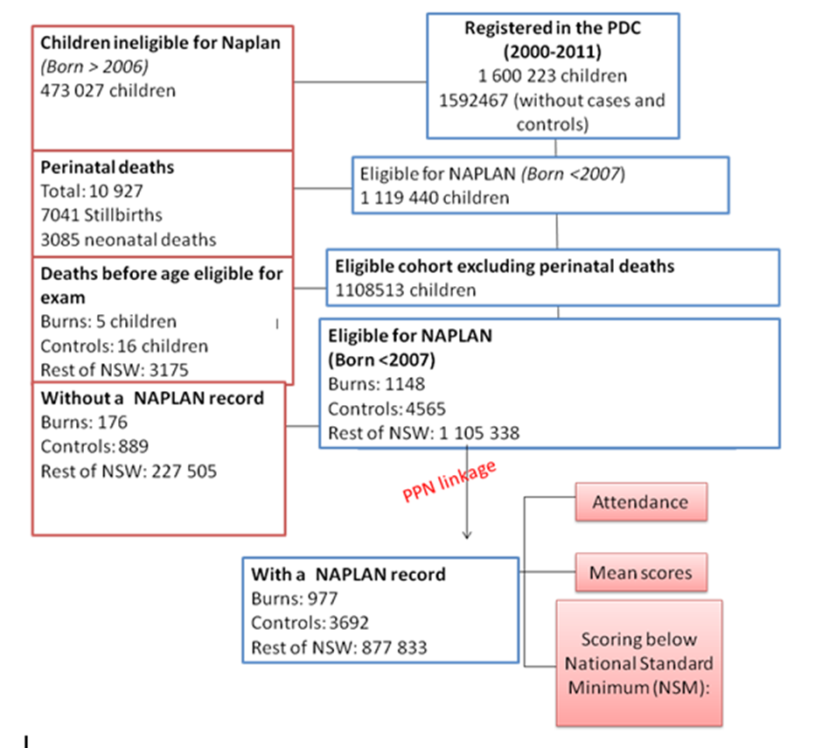
Appendix B
Percentage of each cohort that scored below NMS- Year 3
Test | Burns (%)  n=941 | Non-burns(%)  (n=3495) | OR (95%CI) | p-value
Grammar/Punctuation | 135 (14.3) | 321(9.2) | 1.64 (1.32 to 2.03) | p<0.001
Reading | 127(13.5) | 299 (8.6) | 1.65 (1.32 to 2.06) | p<0.001
Spelling | 125 (13.3) | 304 (8.7) | 1.60 (1.28 to 2.00) | p<0.001
Writing | 110 (11.7) | 168 (4.8) | 1.68 (1.32-2.12) | p<0.001
Numeracy | 118 (12.5) | 318 (9.1) | 1.42 (1.13-1.78) | p<0.01
Rates in each cohort that scored below NMS- Year 5
Test | Burns (%)  n=677 | Non burns(%)  (n=2481) | OR (95%CI) | p-value
Grammar/Punctuation | 106 (15.7) | 269 (10.8) | 1.53 (1.20 to 1.95) | <0.001
Reading | 104 (15.4) | 268 (10.8) | 1.50 (1.17 to 1.90) | <0.01
Spelling | 98 (14.5) | 223 (9.0) | 1.72 (1.33 to 1.24) | <0.01
Writing | 126 (18.6) | 287 (11.6) | 1.75 (1.39 to 2.20) | <0.001
Numeracy | 79 (11.7) | 263 (10.6) | 1.11 (0.85 to 1.46) | 0.44
Rates in each cohort that scored below NMS- Year 7
Test | Burns (%)  n=677 | Non burns(%)  (n=2481) | OR (95%CI) | p-value
Grammar/Punctuation | 57 (15.1) | 156 (12.8) | 1.39 (1.00 to 1.94) | 0.06
Reading | 49 (13.0) | 127 (10.4) | 1.47 (1.03 to 2.09) | <0.05
Spelling | 98 (26.0) | 223 (18.2) | 1.26 (0.87 to 1.83) | 0.24
Writing | 65 (17.2) | 182 (14.9) | 1.37 (1.00 to 1.87) | 0.05
Numeracy | 37 (9.8) | 112 (9.2) | 1.22 (0.83 to 1.81) | 0.35

