Appendices

Appendix 1. The ascertainment of 127 children in the Community and 245 children in the ED cohort
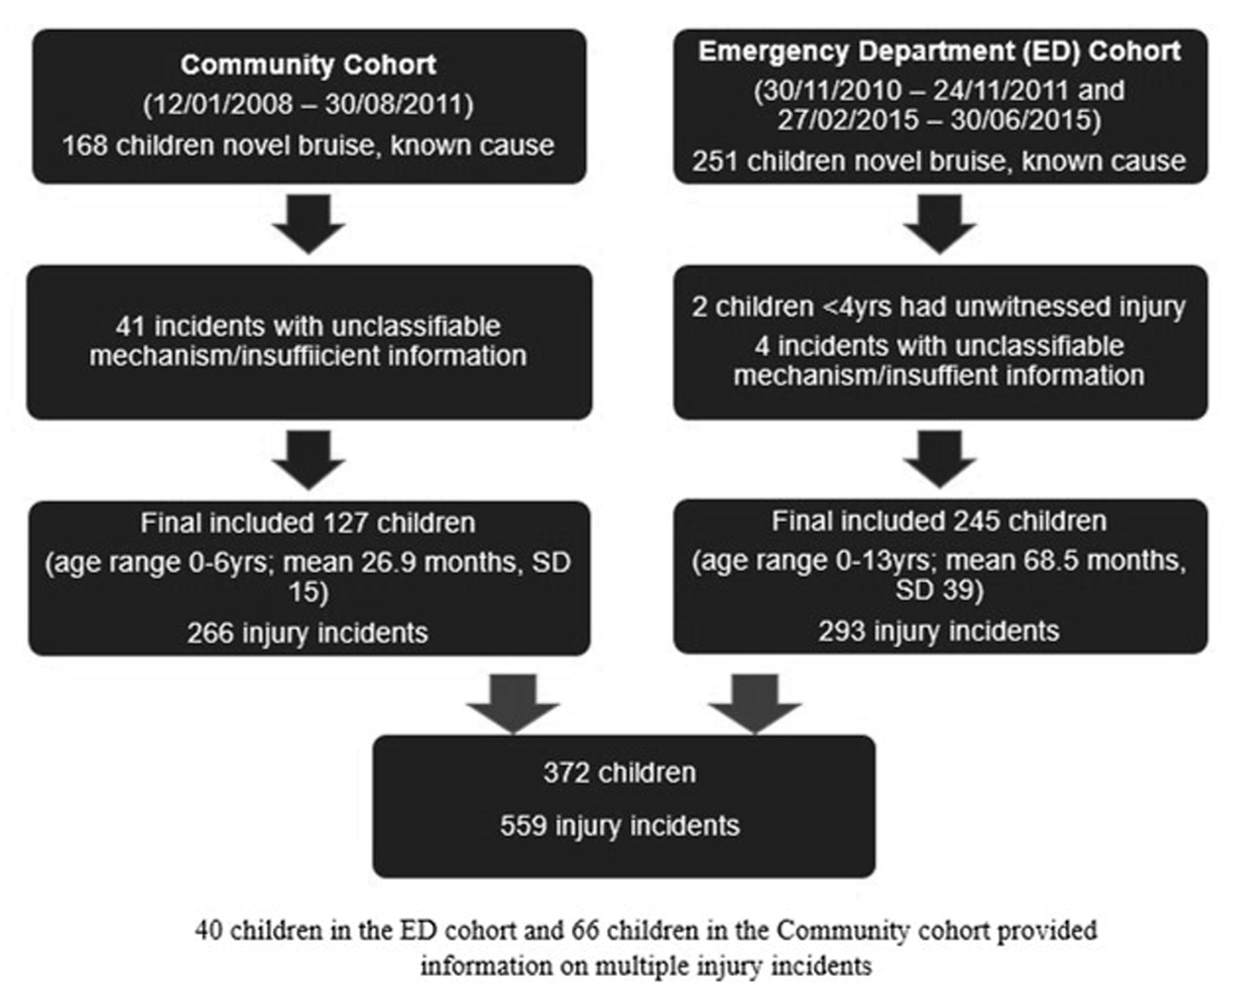

Appendix 2. Further detail on mechanisms of injury from 559 incidents in children <13yrs
 |  | Number of incidents | Number of bruises |  |  |  | Total number of bruises | Common sites of bruising
 |  |  | 1 | 2 | 3 | 4 |  | Below knee - front | Knee | Forehead | Head | Other
Number of Stairs fallen downª | 0 – 9 | 10 | 7 | 3 | 0 | 0 | 13 | 1 | 1 | 5 | 1 | 5
 | 10 – 14 | 6 | 0 | 3 | 2 | 1 | 16 | 1 | 0 | 5 | 2 | 8
 | Unknown | 9 | 7 | 1 | 1 | 0 | 12 | 4 | 0 | 1 | 0 | 7
 | Total | 25 | 14 | 7 | 3 | 1 | 41 | 6 | 1 | 11 | 3 | 20
Impact Injury | Hit by moving object | 46 | 45 | 1 | 0 | 0 | 47 | 6 | 3 | 14 | 2 | 22
 | Hit a stationary object | 96 | 91 | 5 | 0 | 0 | 101 | 25 | 2 | 30 | 9 | 35
Type of Sporting Event^{b} | Football | 22 | 11 | 8 | 2 | 1 | 37 | 27 | 6 | 0 | 0 | 4
 | Rugby | 5 | 4 | 1 | 0 | 0 | 6 | 1 | 2 | 0 | 1 | 2
 | Scooter or skateboarding | 14 | 6 | 5 | 3 | 1 | 29 | 9 | 9 | 2 | 0 | 9
 | Cycling | 14 | 9 | 5 | 0 | 0 | 18 | 10 | 1 | 3 | 0 | 4
 | Other | 3 | 2 | 1 | 0 | 0 | 4 | 1 | 0 | 0 | 0 | 3
 | Total | 58 | 31 | 20 | 5 | 2 | 94 | 48 | 18 | 5 | 1 | 22
ª1 x carried by care giver (unknown number of steps and 1 bruise), 1 x in buggy (12 steps, 3 bruises), 1 x on tricycle (2 steps, 2 bruises)
^{b}Other sporting events – 1 x karate, 1 x skiing and 1 x trampolining

Statistical Appendices

Statistical Appendix 1. Difference in gender across mechanisms of injury for 559 injury incidents
 |  | Mechanism
 |  | Fall from < 1 metre | Fall from standing height or less and hitting an object during fall | Fall from 1 - 2 metres | Stair fall | Impact into an object | Sports injury | Motor vehicle collision | Crush injury | Total
Boy | Number | 88 | 51 | 10 | 10 | 71 | 47 | 6 | 4 | 287
 | % | 30.7% | 17.8% | 3.5% | 3.4% | 24.7% | 16.4% | 2.1% | 1.4% | 100.0%
Girl | Number | 110 | 45 | 14 | 15 | 71 | 11 | 1 | 5 | 272
 | % | 40.4% | 16.5% | 5.1% | 5.5% | 26.1% | 4.0% | 0.4% | 1.8% | 100.0%
Total | Number | 198 | 96 | 24 | 25 | 142 | 58 | 7 | 9 | 559
The mechanism of bruising was significantly (p < 0.001) different boys and girls. Note this primarily due to sports injury. There is no overall significant difference if sports injury is excluded (p = 0.29)

Statistical Appendix 2. Method of presentation from 559 incidents of injury in children aged <13 years
Method of Presentation |  | Total number of incidents  (% of total incidents of injury) | Fall from < 1 metre  (% for this mechanism) | Fall from standing height  or less & hitting an object during fall (% for this mechanism) | Fall from 1 - 2 metres  (% for this mechanism) | Stair fall  (% for this mechanism) | Impact injury  (% for this mechanism) | Sports injury  (% for this mechanism) | Motor vehicle collision  (% for this mechanism) | Crush injury  (% for this mechanism)
Medically attended |  | 146  (26.1) | 49  (24.8) | 17  (17.7) | 17  (70.8) | 15  (60.0) | 23  (16.1) | 13  (22.4) | 7  (100.0) | 5  (55.6)
Non-medically attended | ED Cohort | 147  (26.3) | 51  (25.7) | 17  (17.7) | 4  (16.7) | 2  (8.0) | 33  (23.1) | 38  (65.5) | 0  (0.0) | 2  (22.2)
 | Community Cohort | 266  (47.6) | 98  (49.5) | 62  (64.6) | 3  (12.5) | 8  (32.0) | 86  (60.8) | 7  (12.1) | 0  (0.0) | 2  (22.2)
Total |  | 559  (100) | 198  (100) | 96  (100) | 24  (100) | 25  (100) | 142  (100) | 58  (100) | 7  (100) | 9  (100)

Statistical Appendix 3. The predicted position of the mechanism by the model against the actual mechanism of injury. Model and test data combined.
Actual Cause | Predicted Position
 | 1st |  | 2nd |  | 3rd |  | Later
Fall from < 1 metre | 125 | 63.1% | 51 | 25.8% | 21 | 10.6% | 1 | 0.5%
Fall from standing height or less and hitting  an object during fall | 34 | 35.4% | 14 | 14.6% | 30 | 31.3% | 18 | 18.8%
Fall from 1 - 2 metres | 2 | 8.3% | 0 | 0.0% | 6 | 25.0% | 16 | 66.7%
Stair fall | 7 | 28.0% | 2 | 8.0% | 2 | 8.0% | 14 | 56.0%
Impact injury | 45 | 31.7% | 80 | 56.3% | 15 | 10.6% | 2 | 1.4%
Sports injuries | 34 | 58.6% | 3 | 5.2% | 13 | 22.4% | 8 | 13.8%
Motor vehicle collision | 5 | 71.4% | 1 | 14.3% | 0 | 0.0% | 1 | 14.3%
Crush injury | 5 | 55.6% | 0 | 0.0% | 2 | 22.2% | 2 | 22.2%
Total | 257 | 46.0% | 151 | 27.0% | 89 | 15.9% | 62 | 11.1%

Statistical Appendix 4. Difference in developmental stage across mechanisms of injury from 559 injury incidents
 |  | Mechanism
 |  | Fall from < 1 metre | Fall from standing height or less and hitting an object during fall | Fall from 1 - 2 metres | Stair fall | Impact into an object | Sports injury | Motor vehicle collision | Crush injury | Total
Baby  Non Mobile | Number | 0 | 0 | 2 | 1 | 4 | 0 | 0 | 0 | 7
 | % | 0.0% | 0.0% | 28.6% | 14.3% | 57.1% | 0.0% | 0.0% | 0.0% | 100.0%
Sitting | Number | 1 | 1 | 0 | 1 | 3 | 0 | 0 | 0 | 6
 | % | 16.7% | 16.7% | 0.0% | 16.7% | 50.0% | 0.0% | 0.0% | 0.0% | 100.0%
Crawling | Number | 5 | 6 | 0 | 0 | 11 | 0 | 0 | 0 | 22
 | % | 22.7% | 27.3% | 0.0% | 0.0% | 50.0% | 0.0% | 0.0% | 0.0% | 100.0%
Cruising | Number | 12 | 15 | 1 | 1 | 19 | 0 | 0 | 0 | 48
 | % | 25.0% | 31.3% | 2.1% | 2.1% | 39.6% | 0.0% | 0.0% | 0.0% | 100.0%
Walking | Number | 180 | 74 | 21 | 22 | 105 | 58 | 7 | 9 | 476
 | % | 37.8% | 15.5% | 4.4% | 4.6% | 22.1% | 12.2% | 1.5% | 1.9% | 100.0%
Total | Number | 198 | 96 | 24 | 25 | 142 | 58 | 7 | 9 | 559
The mechanism of bruising was significantly different (p < 0.001) across the development stages

