Contents of Online only material
eTable 1: Codes used to indicate an instance of surgical treatment for developmental dysplasia of the hip on national hospital discharge records 1
eTable 2: Children born 1997/98 to 2012/13: cumulative number undergoing first surgical intervention for DDH by age up to 16 years, Scotland 3
eFigure 2: Relative risk for difference in risk for pre-introduction versus post-introduction time periods for intervention areas compared to non-intervention areas: sensitivity analysis comparing different definitions for the intervention period 4
eMethods 4
Systematic search 4
eResults 4
Systematic search 4
Summary statistics for NHS Lothian, NHF Fife and Scotland 6
Population statistics for Fife, Lothian and Scotland 6
Births and deaths for Fife, Lothian and Scotland 6
Life expectancy statistics for Fife, Lothian and Scotland 7
Socio-economic status measures for Fife, Lothian and Scotland 7
Maternal and early years health statistics for Fife, Lothian and Scotland 7
Primary school-aged child health markers for Fife, Lothian and Scotland 8
Migration in Scotland 8
Inward Overseas Migration 8

eTable 1: Codes used to indicate an instance of surgical treatment for developmental dysplasia of the hip on national hospital discharge records

ICD10 diagnosis code
Q65.0 | Congenital dislocation of hip, unilateral
Q65.1 | Congenital dislocation of hip, bilateral
Q65.2 | Congenital dislocation of hip, unspecified
Q65.3 | Congenital subluxation of hip, unilateral
Q65.4 | Congenital subluxation of hip, bilateral
Q65.5 | Congenital subluxation of hip, unspecified
Q65.6 | Unstable hip
Q65.8 | Other congenital deformities of hip
Q65.9 | Congenital deformity of hip, unspecified
OPCS4 procedure code
T70.2 | Adjustment to length of tendon - Tenotomy NEC
T70.5 | Adjustment to length of tendon - Lengthening of tendon
W13.4 | Other periarticular division of bone - Relocation and derotation osteotomy
W14.4 | Diaphyseal division of bone - Rotation diaphyseal osteotomy and internal fixation HFQ
W16.4 | Other division of bone - Osteotomy and internal fixation NEC
W16.9 | Other division of bone - Unspecified
W28.1 | Other internal fixation of bone - Application of internal fixation to bone NEC
X22.1 | Open reduction of congenital deformity of hip
X22.2 | Primary osteotomy of pelvis for correction of congenital deformity of hip
X22.3 | Secondary arthroplasty of hip for correction of congenital deformity of hip
X22.4 | Intra-articular soft tissue procedures for correction of congenital deformity of hip
X22.5 | Extra-articular procedures for correction of congenital deformity of hip
X22.8 | Other specified correction of congenital deformity of hip
X22.9 | Unspecified correction of congenital deformity of hip
W65 | Primary open reduction of dislocation of joint (with site code Z84.3)
W66 | Primary closed reduction of dislocation of joint (with site code Z84.3)
General hospital discharge (SMR01) records indicating surgical treatment of DDH were those with a relevant diagnostic and procedure code in the main or subsequent position

eTable 2: Children born 1997/98 to 2012/13: cumulative number undergoing first surgical intervention for DDH by age up to 16 years, Scotland
 |  | Age (years)
Year of birth | Live births | 1 | 2 | 3 | 4 | 5 | 6 | 7 | 8 | 9 | 10 | 11 | 12 | 13 | 14 | 15 | 16
1997/98 | 58,689 | 44 | 65 | 76 | 78 | 81 | 84 | 86 | 88 | 91 | 91 | 93 | 95 | 98 | 98 | 98 | 98
1998/99 | 56,962 | 29 | 57 | 66 | 67 | 71 | 72 | 75 | 77 | 77 | 78 | 79 | 79 | 80 | 81 | 82
1999/00 | 54,869 | 33 | 67 | 75 | 81 | 84 | 86 | 87 | 87 | 89 | 89 | 90 | 90 | 90 | 92
2000/01 | 52,879 | 23 | 56 | 61 | 66 | 69 | 70 | 72 | 75 | 76 | 77 | 77 | 79 | 79
2001/02 | 51,578 | 36 | 65 | 71 | 73 | 73 | 75 | 75 | 75 | 77 | 77 | 80 | 81
2002/03 | 51,462 | 21 | 45 | 56 | 58 | 61 | 61 | 61 | 63 | 64 | 64 | 64
2003/04 | 53,141 | 24 | 52 | 60 | 61 | 64 | 64 | 65 | 66 | 66 | 66
2004/05 | 54,124 | 26 | 61 | 69 | 75 | 77 | 78 | 80 | 80 | 80
2005/06 | 54,373 | 26 | 67 | 73 | 76 | 78 | 78 | 80 | 80
2006/07 | 56,486 | 29 | 58 | 68 | 72 | 73 | 74 | 75
2007/08 | 58,689 | 35 | 64 | 77 | 77 | 79 | 79
2008/09 | 59,435 | 23 | 58 | 66 | 68 | 69
2009/10 | 59,155 | 26 | 52 | 59 | 62
2010/11 | 58,633 | 16 | 42 | 50
2011/12 | 58,817 | 16 | 36
2012/13 | 57,302 | 10

eFigure 1: Relative risk for difference in risk for pre-introduction versus post-introduction time periods for intervention areas compared to non-intervention areas: sensitivity analysis comparing different definitions for the intervention period
Point estimates and upper and lower 95% confidence intervals, which were obtained from the difference-in-difference logistic regression model of risk of surgery on area and time-period

eMethods

Systematic search
We examined whether different screening strategies increased early detection reduced surgery for developmental dysplasia of the hip.
Our eligibility criterion was any intervention study with a control group (including geographical or historical controls) comparing different screening strategies for identifying development dysplasia of the hip with outcome data on late diagnosis of DDH and/or surgery for DDH.
A systematic review has recently been completed on this topic, a January 2011 Cochrane systematic review “Screening programmes for developmental dysplasia of the hip in newborn infants”, which used a broad search strategy to identify randomised and pseudo-randomised trials of different screening strategies.⁵ Therefore, we updated this search on the 1st of May 2017 using the original search terms and databases (“infant, newborn”, “hip dislocation, congenital” and “mass screening” in MEDLINE, Embase and Cochrane Central Register of Controlled Trials (CENTRAL) databases, limiting the study to publications from January 2011 onwards. We also revisited for eligibility the 10 studies excluded from the original review, in view of our broader inclusion criteria.

eResults

Systematic search

MEDLINE Search (conducted in PUBMED)
 | Terms | Results
#1 | Search " infant, newborn"[mh] | 546582
#2 | Search "hip dislocation, congenital"[MH] | 7259
#3 | Search "mass screening"[MH] | 110956
#4 | Search (#1 AND #2) | 2058
#5 | Search (#4 AND #3) | 408
#6 | Search (#4 AND #3) Filters: Publication date from 2011/01/31 to 2017/05/01 | 50

Embase search
 | Terms | Results
#1 | newborn/ | 544346
#2 | congenital hip dislocation/ | 5478
#3 | mass screening/ | 52796
#4 | hip dysplasia/ | 5253
#5 | 2 or 4 | 10415
#6 | 1 and 3 and 5 | 82
#7 | limit 6 to yr="2011 -Current" | 6

CENTRAL search
ID | Search | Hits
#1 | MeSH descriptor: [Infant, Newborn] explode all trees | 14992
#2 | MeSH descriptor: [Hip Dislocation, Congenital] explode all trees | 77
#3 | MeSH descriptor: [Mass Screening] explode all trees | 5600
#4 | #1 and #2 and #3 | 12
Manually | Limit to on or after 2011 | 1

In our updated search, we identified 50 papers in Medline, 6 papers in EMBASE and 5 trials in CENTRAL. All the papers identified in CENTRAL and 5 of the 6 EMBASE papers were duplicates of those in Medline. The paper unique to Embase did not include a control group. Of the 50 papers identified via medline, 8 were not studies of screening methods, 1 examined pre-term infants, 17 were review/educational/opinion articles, 19 had no control of any kind (historical or geographical) and 1 was an extension to a clinical trial which did not report functional outcomes. None of the 10 studies excluded from the 2011 Cochrane review were suitable for inclusion in our analysis, 1 study was a cost-effectiveness analysis of existing data, 5 had no control group, 1 randomised control trial compared neonatal screening more broadly, 1 was a letter reporting a historical change in costs from surgery, but without outcome data, 1 was a qualitative study of midwife versus doctor assessments and 1 could not be analysed as all patients received ultrasound scanning at 6-months.
Of the 2 studies meeting our criteria, one was a case-control study set in Germany. 446 cases were identified from national data, and 1173 controls were identified for the same time-period and area. Whether cases and controls had undergone ultrasound screening was identified by questionnaire. The odds ratio for ultrasound was 0.41 (95%CI 0.31-0.55) consistent with ultrasound being protective.²¹ A second study compared incidence counts for DDH surgery in a single region of Australia between two four-year periods before (1978 to 1982) and after (1993 to 1997) the adoption of a country-wide universal ultrasound screening programme.²⁰ In children aged less than 1 ½ years old, open and closed reduction fell from 126 to 35 and 14 to 7 respectively, while children aged between 1 ½ and 15 years old the count of acetabular osteotomies/ varus derotation osteotomy fell from 89 to 13.
The 2011 Cochrane review identified 1 trial comparing clinical examination to universal as well as to targeted ultrasound. The point estimate for both suggested a reduction in late diagnosis (RR 0.54; 95%CI 0.19-1.59 and 0.80; 95% CI 0.33-1.98 respectively) and in surgery (RR 0.22; 95% CI 0.01-4.52 and 0.45; 95% CI 0.04-4.93) but with only 11,925 participants and very low event rates the confidence intervals were wide, being consistent with no benefit and even harm.

Summary statistics for NHS Lothian, NHS Fife and Scotland
The following plots show summary statistics for Fife, Lothian and Scotland. All of these statistics are in the public domain, having been published by the Scottish Public Health Observatory. These are shown below to help readers understand the intervention areas in the context of the rest of Scotland, and their own populations. Please see http://www.scotpho.org.uk/comparative-health/profiles/online-profiles-tool for a detailed description of each statistic, additional figures and data tables (including in a downloadable format).

Population statistics for Fife, Lothian and Scotland
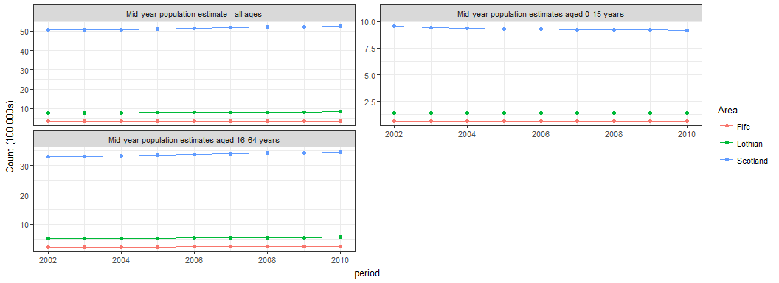

Births and deaths for Fife, Lothian and Scotland
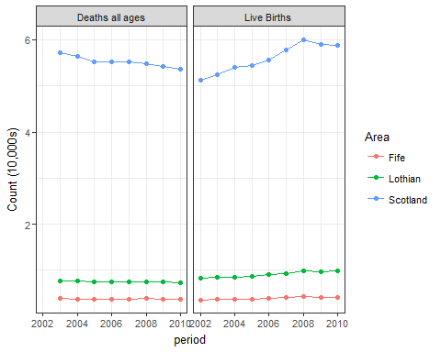

Life expectancy statistics for Fife, Lothian and Scotland
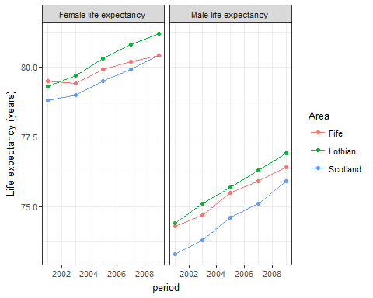

Socio-economic status measures for Fife, Lothian and Scotland
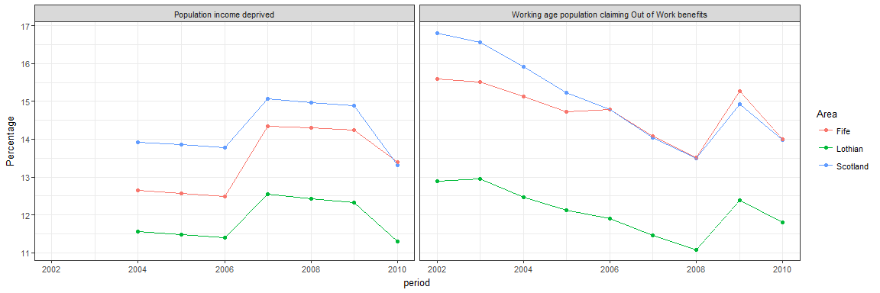

Maternal and early years health statistics for Fife, Lothian and Scotland
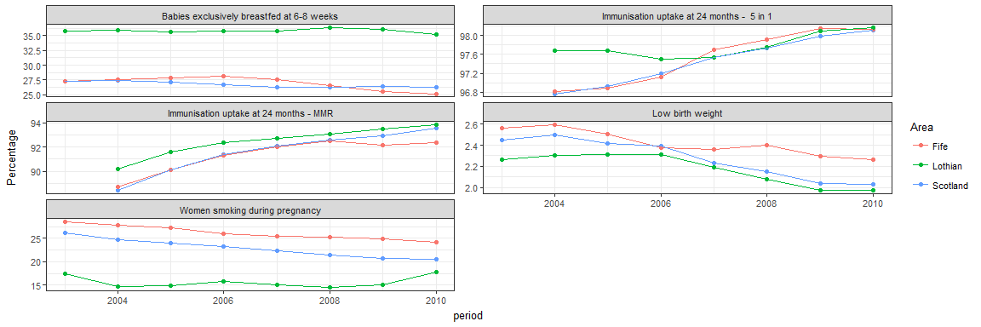

Primary school-aged child health markers for Fife, Lothian and Scotland
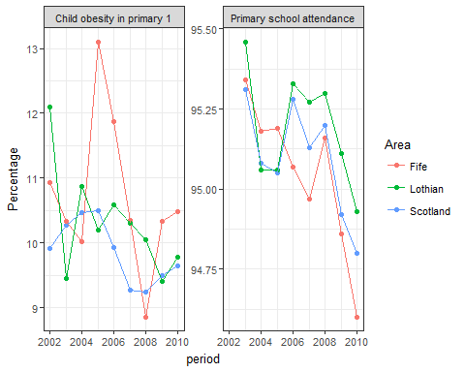

Migration in Scotland
The following data were obtained from National Records of Scotland (NRS) website “Migration to and from administrative areas, 2001-02 – latest, Scottish administrative areas”. The definition and methods for defining inward migration is available from the NRS website (https://www.nrscotland.gov.uk/statistics-and-data/statistics/statistics-by-theme/migration/methodology). This does include asylum seekers, but excludes movements of prisoners and armed forces personnel. Notably the inward migration was not greater in non-intervention areas, and hence this inward migration not a plausible explanation for the fact that despite falling in Lothian and Fife, rates of surgery remained high in the rest of Scotland.

Inward Overseas Migration
Year | Intervention areas (Fife and Lothian) | Non-Intervention areas | Percentage in intervention areas
2001 | 15945 | 38452 | 29.3
2002 | 14695 | 39601 | 27.1
2003 | 16255 | 45624 | 26.3
2004 | 15676 | 41666 | 27.3
2005 | 15406 | 37929 | 28.9
2006 | 14256 | 37290 | 27.7
2007 | 15173 | 38154 | 28.5
2008 | 13108 | 32299 | 28.9
2009 | 13510 | 31497 | 30
2010 | 12842 | 30844 | 29.4
2011 | 13037 | 32079 | 28.9

